Fresh bites caterinG

REPORT

INTRODCTION:

1.1.OVERVIEW:

Fresh Bites Catering, a catering service, utilizes Zoho Books to manage their sales, track inventory, and handle invoicing. They can generate professional invoices for clients and track expenses related to ingredients and supplies. Zoho Books helps them maintain accurate financial records and streamline their catering operations.

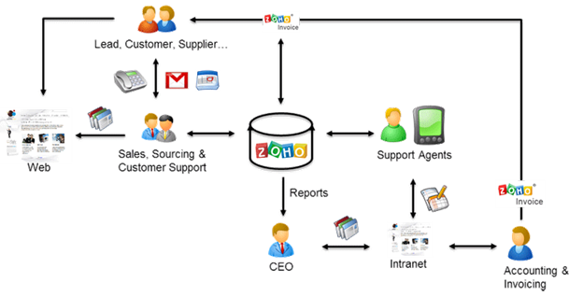

1.2. PURPOSE:

Fresh bites catering, A catering service, utilizes ZOHO books to manage their sales, track inventory, and handle invoicing. They can generate professional invoices for clients and track expenses related to ingredients and supplies.

USAGE:

ZOHO books is your one stop platform for managing your accounting tasks and organizing your transactions. It’s a single secure location to keep up with your company’s bills and invoices. Reconcile your bank statements, control your spending, oversee projects, and eliminate GST compliance worries.

PROBLEM DEFINITION & DESIGN THINKING:

i)Improving customer service….

ii) ZOHO streamlines customer grievance Redressal…..

iii)Measuring the business impact…..

iv)Improves collaboration between teams….

v)Access data at any time and from anywhere….

2.1.EMPATHY MAP:

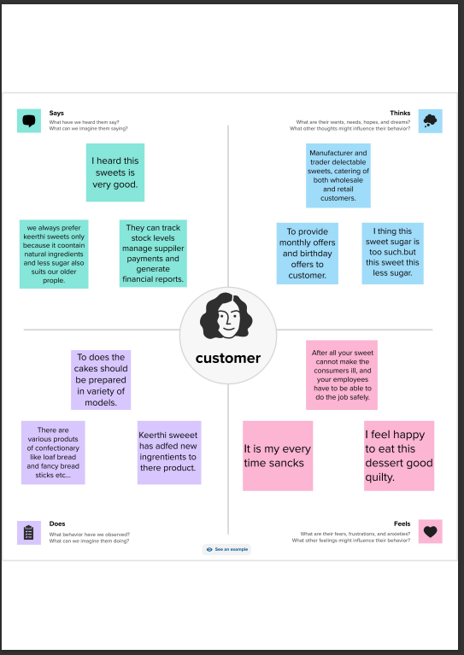

2.2.IDEATION & BRAINSTORMING:

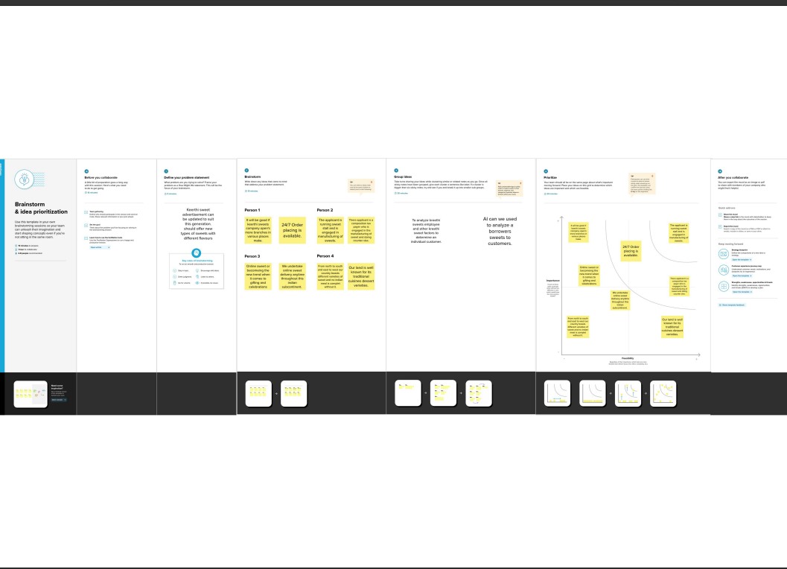

3. RESULT:

COMPANY NAME CREATION: FRESH BITES CATERING (PRIYADHARSHINI)

OUTPUT:

1.ITEM CREATION:

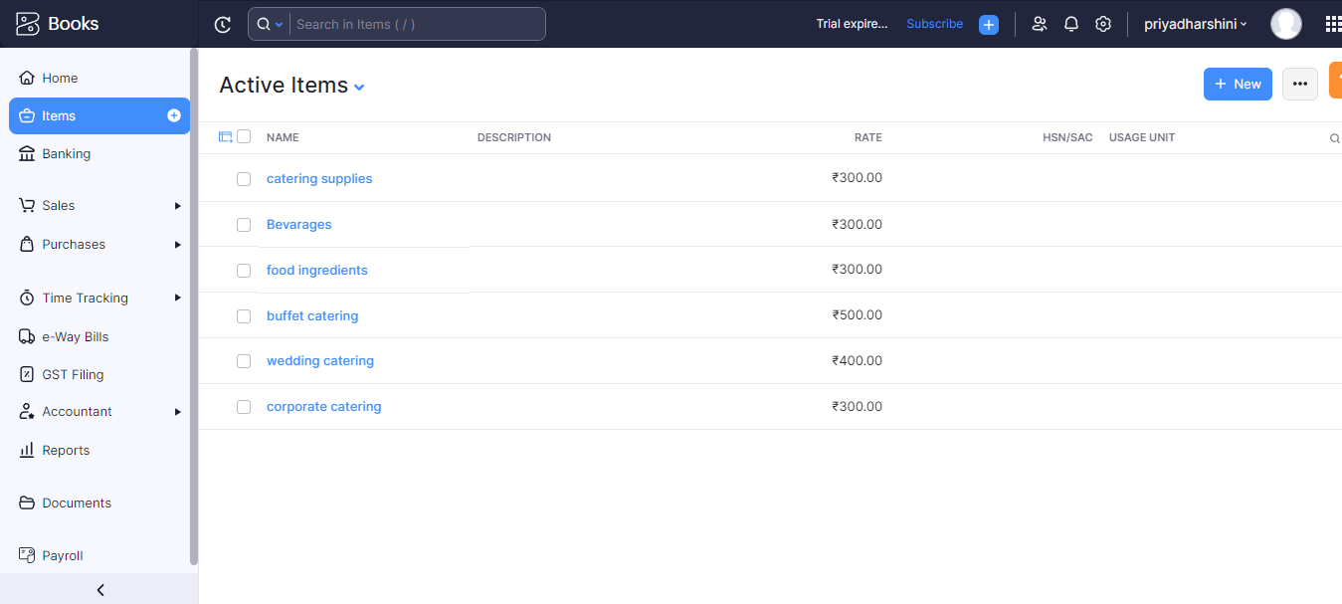

2.VENDOR CREATION:

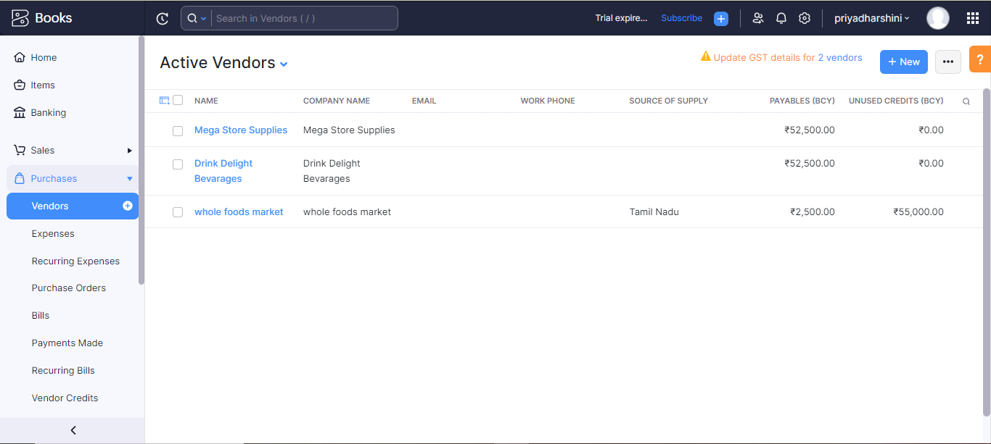

3.PURCHASE ORDER:

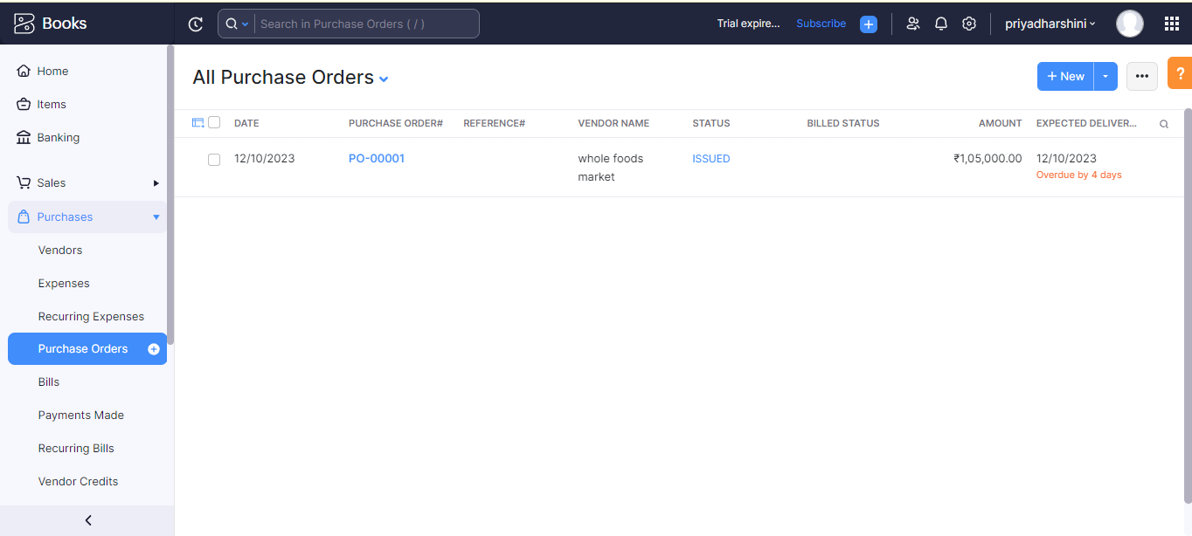

4.SALES ORDER:

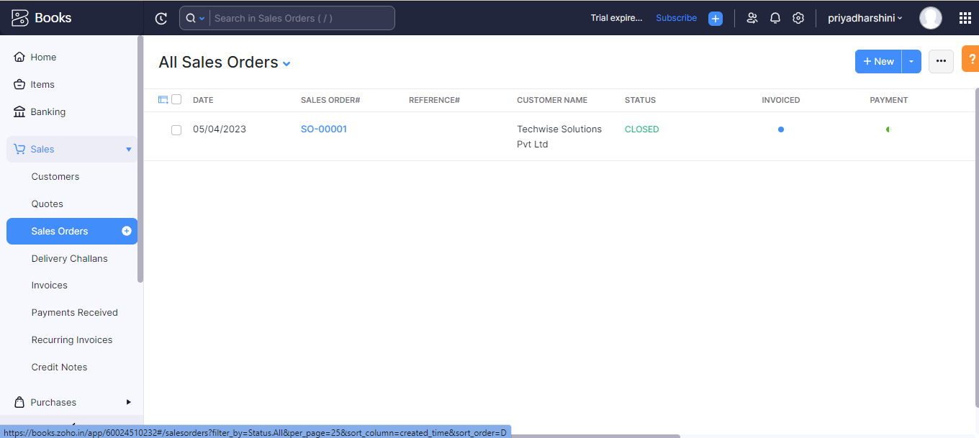

5.ICICI BANK TRANSACTIONS:

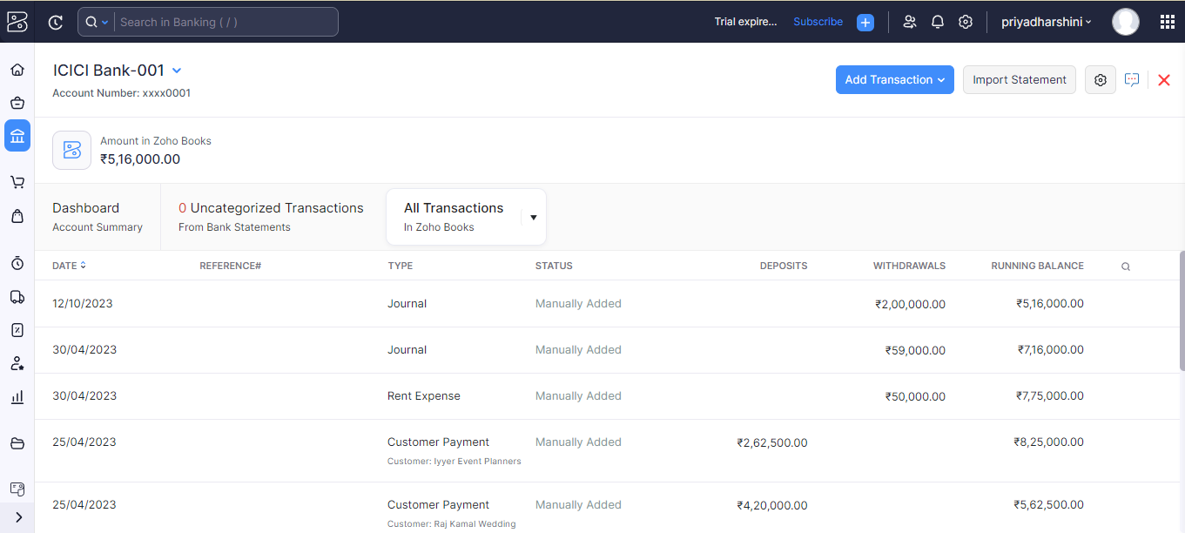

6.PROFIT AND LOSS ACCOUNT:

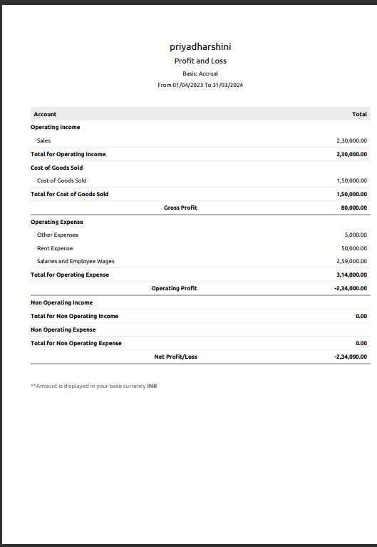

7.BALANCE SHEET:

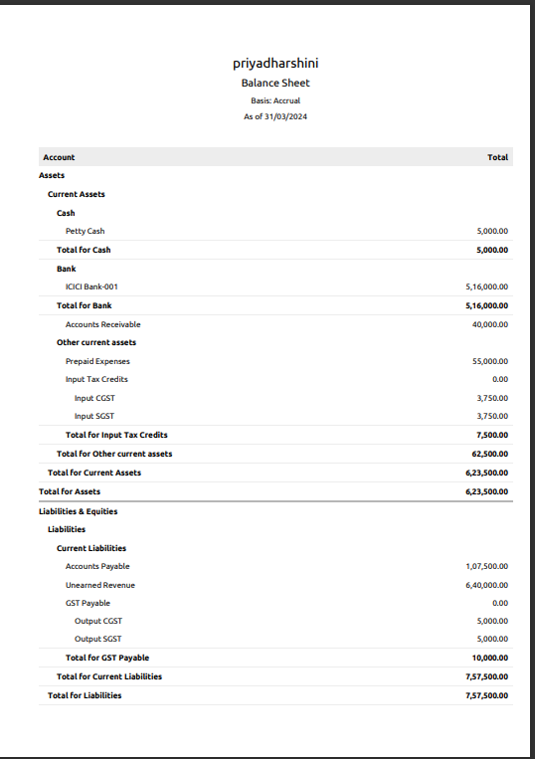

ADVANTAGES & DISADVANTAGES:

i)Monthly transaction cap…

ii)Multiple subscriptions for multiple businesses.

iii) Additional users require a fee…

iv) Fewer integrations than competitors….

v) No payroll services….

vi) Accounts payable limitations….

APPLICATIONS:

Managing accounting on the go with ZOHO books ios and android apps. Do your accounting on the go using the mobile app for ios, android, and windows.

CONCLUSION:

ZOHO books are provided future technology for going on business and supports students project. It is easy to use and access too.

FUTURE SCOPE:

Preparing and strong food safety before during events,setting,up all tablets and food service areas with the chairs,lines,and dishes,services,food to guests,at events. It also helped to reduce the work of the accountant to maintain accounts.

APPENDIX:

A SOURCE CODE: COMPUTER DATA

i)Approved developments

ii)Future assessments

iii)Plan of development

iv)Convactiess free delivery and pickup.

EMPATHY MAP & BRAINSTORMING:

[https://github.com/mtu121ucom041/preparation-and -maintenance-of-ZOHO-BOOKS-for-keerthi-sweets/commit/4c17cabde896b9a4333ebf9012611a19d506f439](https://github.com/mtu121ucom041/preparation-and%20-maintenance-of-ZOHO-BOOKS-for-keerthi-sweets/commit/4c17cabde896b9a4333ebf9012611a19d506f439)

ZOHO BOOK LINK:

Zoho.book.com